The practical activity in unit 3 involves me using a trace route which is a command line utility to identify the exact path a data packet takes in terms of route connected to as it travels across the internet. (from the sender to its destination in this case a hosted server www.allmytpe.co.uk). This concept helps to identify bottlenecks in the process like where and why server are timing outs or lagging

Performing this activity on Microsoft windows 10 OS, 13 hoops were discovered with highest hoop in terms of delay at step 7. Round trip time was completed at 76Ms duration on average suggesting the route might just be too most far away from the next route. (long distance between route 6 and 7 and 8) and not necessarily a lag. Had it been there was a consistent rise in the round trip time from hoop 7 towards the ends hoops then this might be a cause for concern

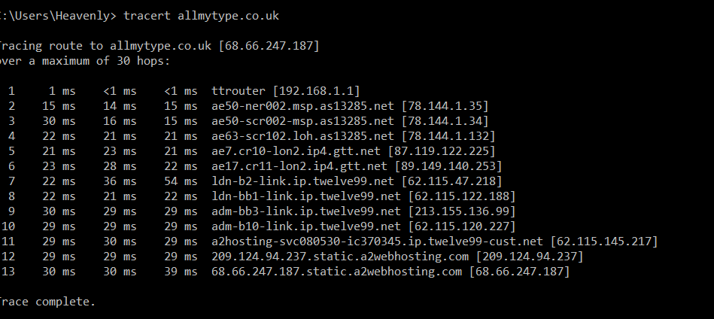



Using WINMTR for further analysis, after running for 12 minutes it was discovered that there were package lost with average of 2.23% but hoop 10 has the highest package loss of 22. This did not suggest much of a problem since it is one off and not a continuation and the latency result did not suggest any upward trend either

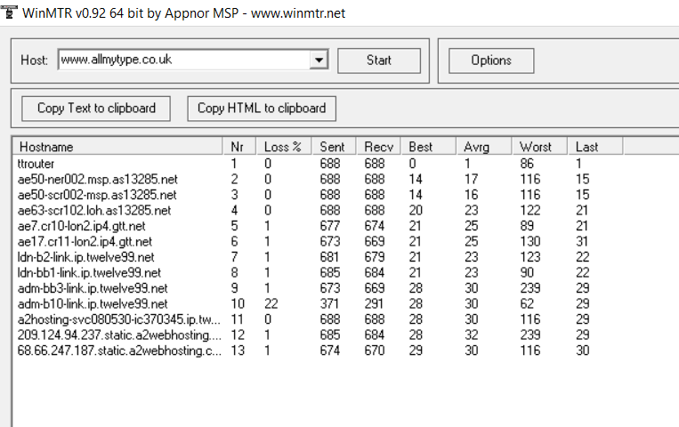



Using nslookup via command line of a window machine the main nameserver and the MX record was determined

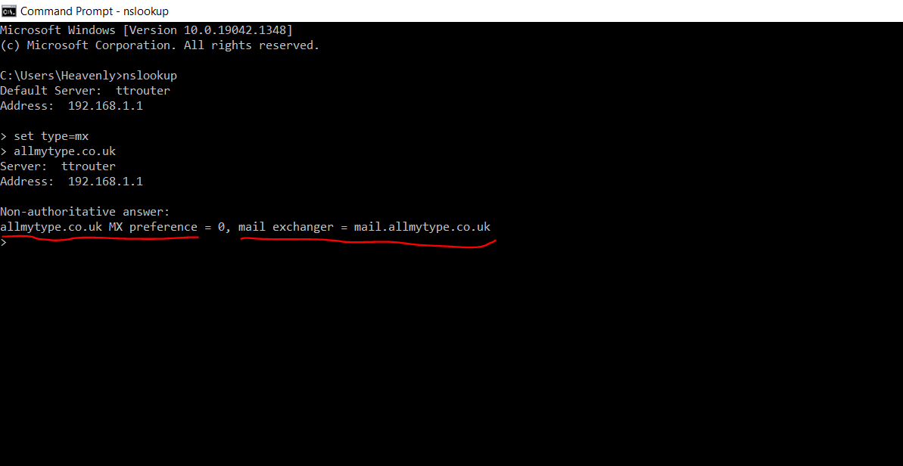

A network search of [WHOIS lookup](http://whois.domaintools.com/) returned information on the registered contact and where the website was hosted

